## CODE WARS SOLUTION | 3.9.2019

**function firstReverseTry(arr) {**

**if (arr.length > 1) {**

**var first = arr[0];**

**arr[0] = arr[arr.length-1];**

**arr[arr.length-1] = first;**

**}**

**return arr**

## **}**

## JS Repl.it Array PRACTICE

// code here

function updateUserInfo(array, propertyKey, propertyValue, newEmail, newName ){

// Loop through the arr

for(let i = 0; i < array.length; i++){

//if the current object has a property name of propertyKey that has the value of propertyValue

if(array[i][propertyKey] === propertyValue){

// update that object's email to newEmail

array[i].email = newEmail;

//name properties to the values newName.

array[i].name = newName;

}

}

// return the array

return array

}

var arr = [{

name: 'James',

email: null,

flag: true

},{

name: 'Dan',

email: null,

flag: false

},{

name: 'JOSH',

email: null,

flag: true

}]

var user0 = {

name: 'James',

email: null,

flag: true

}

console.log(updateUserInfo( [ user0 ], 'name', 'James', 'email@domain.com', 'Bob' ));

## Ternary 1.3

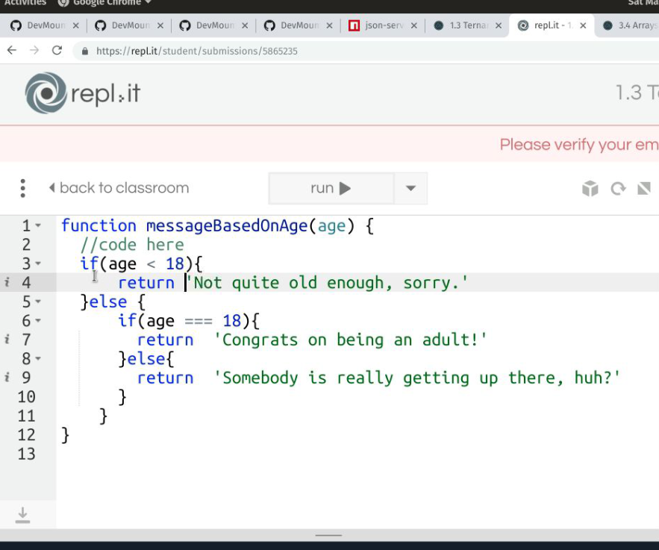

**Warning**: These steps will **permanently** delete the repository, wiki, issues, and comments. This action **cannot** be undone.

Please also keep in mind that:

* Deleting a private repository will delete all of its forks.
* Deleting a public repository will not delete its forks.

1. On GitHub, navigate to the main page of the repository.
2. Under your repository name, click  **Settings**.

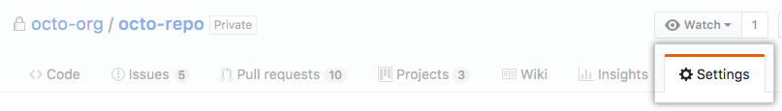

1. Under Danger Zone, click **Delete this repository**.

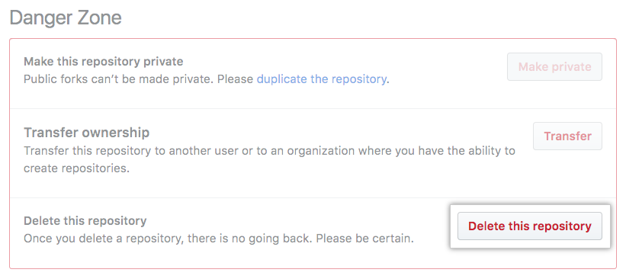

1. **Read the warnings**.
2. To verify that you're deleting the correct repository, type the name of the repository you want to delete.

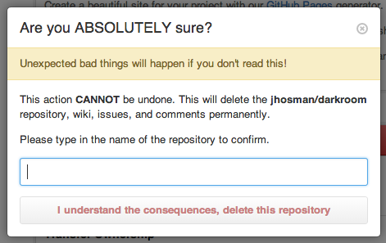

1. Click **I understand the consequences, delete this repository**.